Rinterio Home Services Portfolio Blogs Contact Us Book Consult 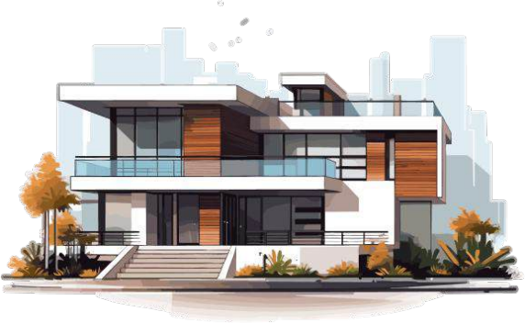

A barn house of this design has a striking appearance

The barn house captivates with its blend of rustic charm and modern sophistication, featuring weathered wood, sleek metal accents, and large windows that flood the space with natural light.

View Details

About Us 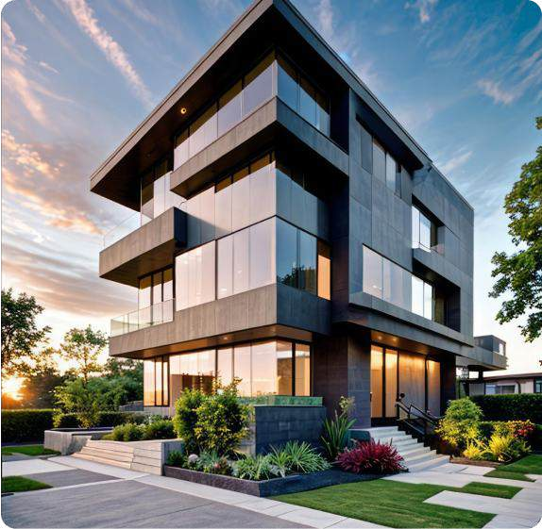

We design thoughtful,

liveable spaces

The barn house captivates with its blend of rustic charm and

modern sophistication, featuring weathered wood, sleek metal accents.

Commercial

The barn house captivates with its blend

of rustic charm and modern.

Residential

The barn house captivates with its blend

of rustic charm and modern.

235+

Happy Client Review

50+

Work Departments

How we works

30k+

Our Happy Client

307+ Staff Members

Our Works Process

The barn house captivates with its blend of rustic charm and modern sophistication, featuring weathered wood, sleek metal accents.

Concept

The barn house captivates with its blend of rustic charm and modern.

Design Process

The barn house captivates with its blend of rustic charm and modern.

Supervision

The barn house captivates with its blend of rustic charm and modern.

Budget Planning

The barn house captivates with its blend of rustic charm and modern.

Explore our Latest works

Our Latest Portfolio

The barn house captivates with its blend of rustic charm and modern sophistication,

featuring weathered wood, sleek metal accents.

Commercial 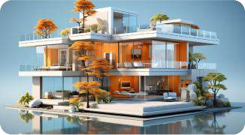

The barn house captivates with its blend of rustic charm

and modern. The barn house captivates with its blend of

rustic charm and modern .

View Details

Commercial 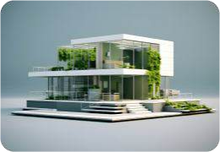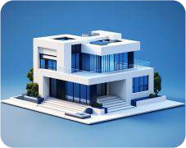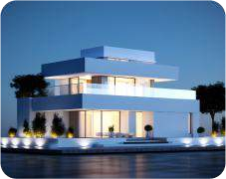

The barn house captivates with

its blend of rustic charm and

modern.

View Details

Rinterio News

Read Our Articles and News

The barn house captivates with its blend of rustic charm and modern sophistication,

featuring weathered wood, sleek metal accents.

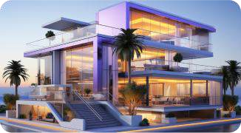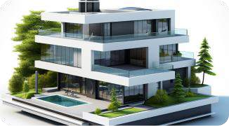

July14, 2024 By Admin

How to choose the furniture right of your home.

The barn house captivates with its blend of rustic charm and modern.

Read More

July14, 2024 By Admin

How to choose the furniture right of your home.

The barn house captivates with its blend of rustic charm and modern.

Read More

Let s Connect

July14, 2024 By Admin

How to choose the furniture right of your home.

The barn house captivates with its blend of rustic charm and modern.

Read More

Let s Discuss Next Project

The barn house captivates with its blend of rustic charm and modern sophistication,

featuring weathered wood, sleek metal accents.

First Name Last Name

Phone Number Email Number

Write your message here

Send Mail

Rinterio

The barn house captivates with its blend of rustic charm and modern sophistication,

featuring weathered wood, sleek metal accents.

Home Services Portfolio Blogs Contact Us Book Consult

Rinterio Book Consult

A barn house of this design has a striking appearance

The barn house captivates with its blend of rustic charm and modern sophistication, featuring weathered wood, sleek metal accents, and large windows that flood the space with natural light.

View Details

About Us

We design thoughtful, liveable spaces

The barn house captivates with its blend of rustic charm and modern sophistication, featuring weathered wood, sleek metal accents.

Commercial

The barn house captivates with its blend of rustic charm and modern.

235+

Happy Client Review

30k+

Our Happy Client

Residential

The barn house captivates with its

blend of rustic charm and modern.

50+

Work Departments

307+

Staff Members

How we works

Our Works Process

The barn house captivates with its blend of rustic charm and modern sophistication, featuring weathered wood, sleek metal accents.

Concept

The barn house captivates with its blend of rustic charm and modern.

Supervision

The barn house captivates with its blend of rustic charm and modern.

Design Process

The barn house captivates with its blend of rustic charm and modern.

Budget Planning

The barn house captivates with its blend of rustic charm and modern.

Explore our Latest works

Our Latest Portfolio

The barn house captivates with its blend of rustic charm and modern sophistication, featuring weathered wood, sleek metal accents.

Commercial

The barn house captivates with its blend of rustic charm

and modern. The barn house captivates with its blend of

rustic charm and modern .

View Details

Commercial

The barn house captivates with its blend of rustic charm

and modern.

View Details

Rinterio News

Read Our Articles and News

The barn house captivates with its blend of rustic charm and modern sophistication, featuring weathered wood, sleek metal accents.

July14, 2024 By Admin

How to choose the furniture right of your

home.

The barn house captivates with its blend of rustic charm and

modern.

Read More

July14, 2024 By Admin

How to choose the furniture right of your

home.

The barn house captivates with its blend of rustic charm and

modern.

Read More

July14, 2024 By Admin

How to choose the furniture right of your

home.

The barn house captivates with its blend of rustic charm and

modern.

Read More

Let s Connect

Let s Discuss Next Project

The barn house captivates with its blend of rustic charm and modern sophistication, featuring weathered wood, sleek metal accents.

First Name Last Name

Phone Number Email Number

Write your message here

Send Mail

Rinterio

The barn house captivates with its blend of rustic charm and modern sophistication, featuring weathered wood, sleek metal accents.

Home Services Portfolio Blogs Contact Us Book Consult

Rinterio

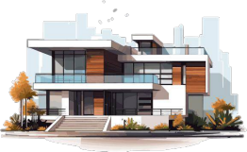

A barn house of this design has a striking appearance

The barn house captivates with its blend of rustic charm and modern sophistication, featuring weathered wood, sleek metal accents, and large windows that flood the space with natural light.

View Details

About Us

We design thoughtful, liveable spaces

The barn house captivates with its blend of rustic charm and modern sophistication, featuring weathered wood, sleek metal accents.

Commercial

The barn house captivates with

its blend of rustic charm and

modern.

Residential

The barn house captivates with

its blend of rustic charm and

modern.

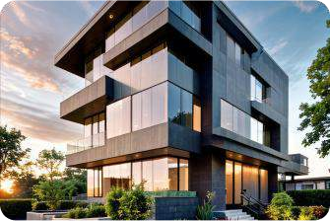

235+

Happy Client Review

50+

Work Departments

30k+

Our Happy Client

307+

Staff Members

How we works

Our Works Process

The barn house captivates with its blend of rustic charm and modern sophistication, featuring weathered wood, sleek metal accents.

Concept

The barn house captivates with its

blend of rustic charm and modern.

Design Process

The barn house captivates with its

blend of rustic charm and modern.

Supervision

The barn house captivates with its

blend of rustic charm and modern.

Budget Planning

The barn house captivates with its

blend of rustic charm and modern.

Explore our Latest works

Our Latest Portfolio

The barn house captivates with its blend of rustic charm and modern sophistication, featuring weathered wood, sleek metal accents.

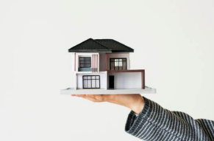Commercial

The barn house captivates with its

blend of rustic charm and modern.

The barn house captivates with its

blend of rustic charm and modern .

View Details

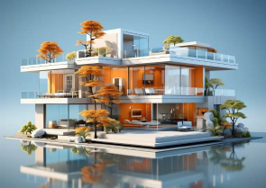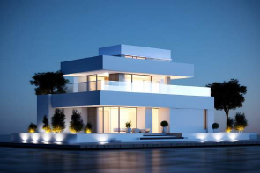Commercial

The barn house captivates with its

blend of rustic charm and modern.

View Details



Rinterio News

Read Our Article and News

The barn house captivates with its blend of rustic charm and modern sophistication, featuring weathered wood, sleek metal accents.

July14, 2024 By Admin

How to choose the furniture right of your home.

The barn house captivates with its

blend of rustic charm and modern.

Read More 

July14, 2024 By Admin

How to choose the furniture right of your home.

The barn house captivates with its

blend of rustic charm and modern.

Read More

July14, 2024 By Admin

How to choose the furniture right of your home.

The barn house captivates with its

blend of rustic charm and modern.

Read More

Let s Connect

Let s Discuss Next

Project

The barn house captivates with its blend of rustic charm and modern sophistication, featuring weathered wood, sleek metal accents.

First Name

Last Name

Phone Number

Email Number

Write your message here

Send Mail

Rinterio

The barn house captivates with its blend of rustic charm and modern

sophistication, featuring weathered wood, sleek metal accents.

Home

Services

Portfolio

Blogs

Contact Us

Book Consult